STATISTICAL INFERENCES FOR THE MEANS
- One-sample t-test:
To do one-sample t test in R, use the command:
t.test(data, mu=hypothesized value)

This test will result a two-tailed test result by default. Thus, if you do a one-tailed test, just make sure to take p value as half as the p-value from R output. Note, the test statistics is still the same.
Also, the default is always 0.05 significant level (or 95% confidence interval).

To change the significant level (or the confidence level), use:
t.test(data, mu=hypothesized value, conf.level = your choice)

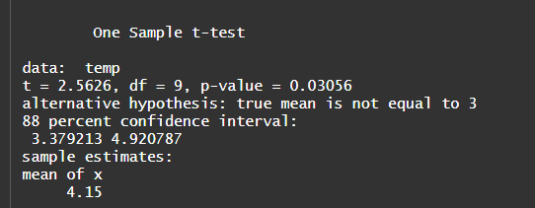
Figure 1: Output of a one-sample t-test

Example 1: A model for a machine suggests that the mean temperature increase in water used as a coolant should not be more than 3 degree Celsius. Tests run on the coolant measured on 10 independent runs reveal the following increases:
Do the data indicate that the mean temperature of the coolant increased significantly more than 3 degree Celcius? Use alpha= 0.05.

- Match paired t-test:
To do match paired t test in R, use the command:
t.test(data_1, data_2, paired= T)

This test will result a two-tailed test result by default. Thus, if you do a one-tailed test, just make sure to take p value as half as the p-value from R output. Note, the test statistics is still the same.
Also, the default is always 0.05 significant level (or 95% confidence interval).

To change the significant level (or the confidence level), use:
t.test(data_1, data_2, paired= T, conf.level = your choice)

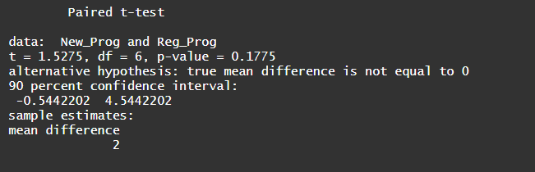
Figure 2: Output of a match paired t-test

Example 2: An educational psychologist has developed an instructional program for children that is designed to promote creative thinking. To test the effectiveness of the program, 14 fifth-grade children are selected at random and paired according to IQ levels. One member of each pair is randomly assigned to regular instruction and the other member to the new program. The scores on a test measuring creativity were as follows:
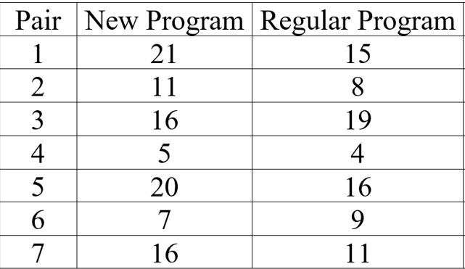
Table 1: Creativity score data
Do the data support the theory that the new problem results in higher creativity score? Use alpha=0.10. How does the result change if we use alpha=0.05?

- Two-sample t-test with unequal variance
To do two-sample t test in R, there are two options (depending on your data set):
- t.test(data_1, data_2, var.equal=F) if your dataset has data 1 in one column and data 2 in another column
- t.test(data~group, var.equal=F) if your dataset has all the data mixed in. THIS IS MORE COMMON.

This test will result a two-tailed test result by default. Thus, if you do a one-tailed test, just make sure to take p value as half as the p-value from R output. Note, the test statistics is still the same.
Also, the default is always 0.05 significant level (or 95% confidence interval). To change the significant level, add the option conf.level in the R command like above.

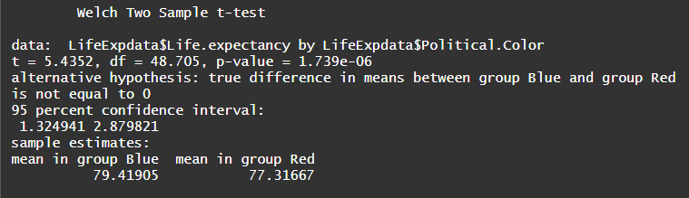
Figure 3: Output of a two-sample t-test with unequal variance

Example 3: Import the data from “LifeExp.csv”. The file has the life expectancy and the political affiliation of each U.S. state. Assuming unequal variance, test if the life expectancy is similar for left-leaning and right-leaning states. Use alpha=0.01.

- Two-sample t test with equal variance
To do two-sample t test in R, there are two options (depending on your data set):
- t.test(data_1, data_2, var.equal=T) if your dataset has data 1 in one column and data 2 in another column
- t.test(data~group, var.equal=T) if your dataset has all the data mixed in. THIS IS MORE COMMON.

This test will result a two-tailed test result by default. Thus, if you do a one-tailed test, just make sure to take p value as half as the p-value from R output. Note, the test statistics is still the same.
Also, the default is always 0.05 significant level (or 95% confidence interval). To change the significant level, add the option conf.level in the R command like above.

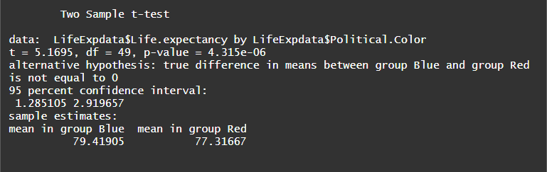
Figure 4: Output of a two-sample t-test with equal variance

Example 3 (Cont’d): Use the same data as above and assuming equal variance, test if the life expectancy is similar for left-leaning and right-leaning states. Use alpha=0.01. Compare your result here and your result above.

